Supplementary materials
Supplemental Figure 37. PF32 phylogeny. The positions of Izh-4 sequences are highlighted.
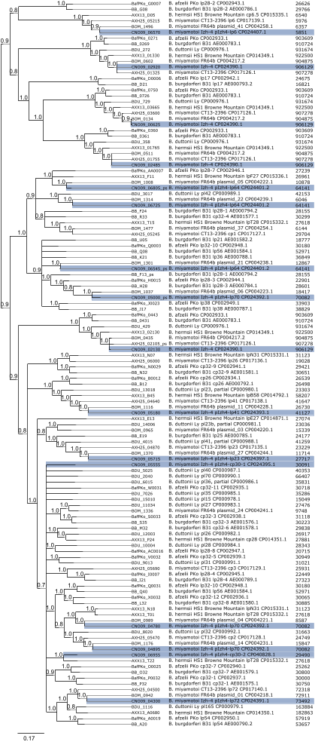

Supplemental Figure 38. PF49 phylogeny.
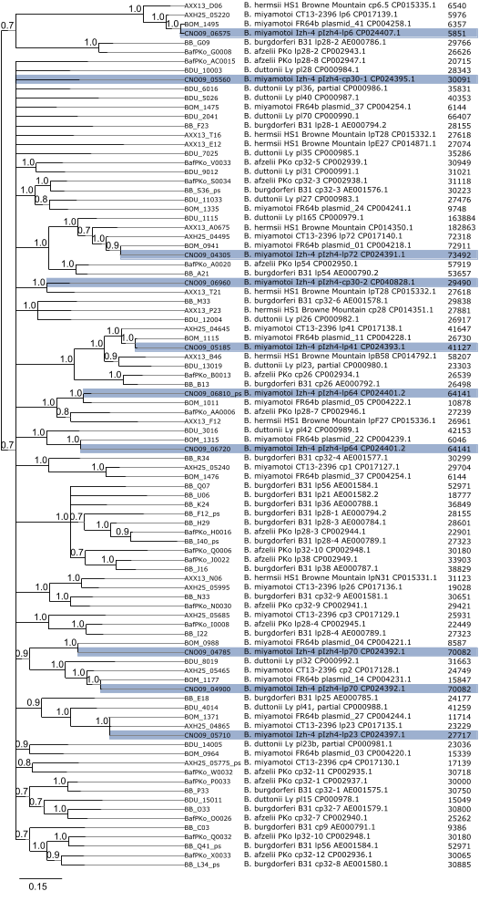

Supplemental Figure 39. PF50 phylogeny.
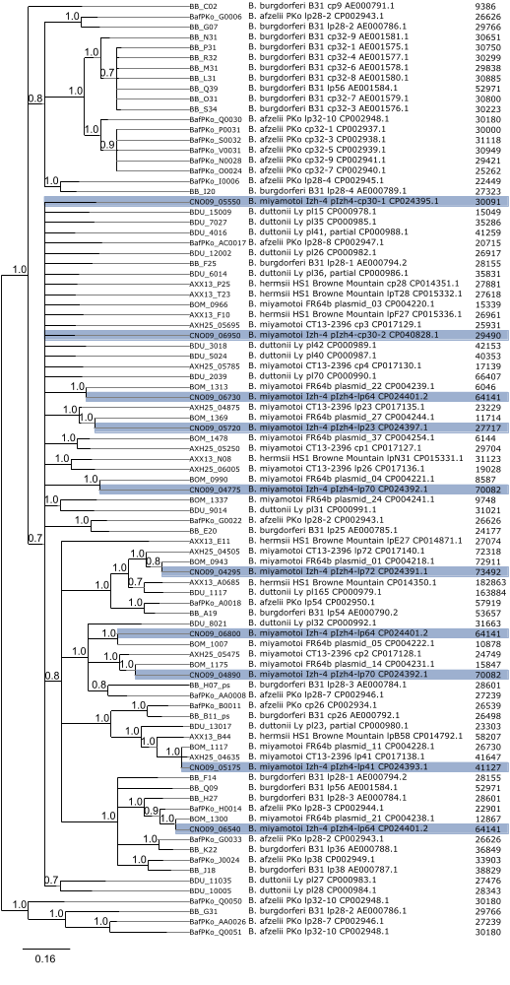

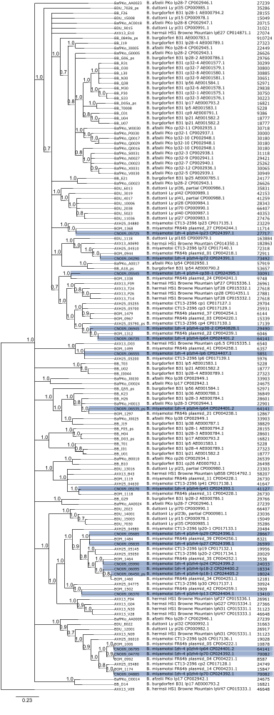
Supplemental Figure 40. PF57/62 phylogeny.

